**First Order Resistor-Capacitor Circuit**

**Lab 8**

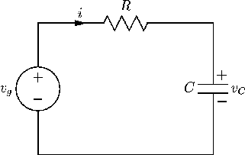

ECE 1101 Lab, Section 6

Date: Thursday, October 17th, 2019

Kyler Martinez, Daniel Tan

Equipment Used In The Experiment:

* Keysight Triple Output DC Power Supply
  + Make/Model: E3630A
  + Serial Number: MY56186189
* Keysight 4 ½ Digital Display Multimeter
  + Make/Model: U3401A
  + Serial Number: MY56150032

Materials Used In The Experiment:

* Breadboard
* 220 µF / 10V Electrolytic Polarized Capacitor
* 100 kΩ, and 1k Ω resistor

Objective:

To measure and validate the electrical behavior of a DC steady-state Resistor-Capacitor (RC) circuit. Then, measuring the time at a voltage to determine the time constant of an RC circuit and the exact value of a capacitor. Finally, plotting the complete voltage response of a series RC circuit and prove the result with the theoretical equations.

Background Theory:

It will take the capacitor voltage of an RC circuit, RC seconds, to get a charge up to .632xE of the chosen value for E from the starting value of 0.

Procedure:

For the first portion of the lab, we are to configure our breadboard to match figure 1 and take the voltage drop across the 1kOhm resistor and the capacitor. Then the current and energy will be calculated to compare with ideal values.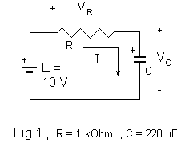

For the second portion of the lab, the 1k resistor is replaced with a 100k ohm resistor, seen in figure 2, and a voltmeter and jumper wire and placed in parallel with the capacitor. After ensuring the voltmeter is reading zero, perform 5 trials where the time it takes for the voltmeter to read 6.32 V. Then the average of the time is averaged, and the capacitor value is calculated.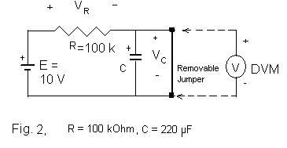

For the final portion of the lab, a similar experiment is performed as the second part except the power supply’s voltage is increased. The capacitor will be shorted and after removing the jumper, the voltage reading will be recorded every ten seconds for 190 seconds.

Data:

Component Measured Values

|  |  |  |  |
| --- | --- | --- | --- |
| Plate Value | 100 kΩ | 1 kΩ | 220 µF |
| Measured Value | 100.62 kΩ | .9936 kΩ | 145 µF |

Part 1

|  |  |  |  |  |  |
| --- | --- | --- | --- | --- | --- |
|  | VC | VR | I= VR/R | W | Q |
| Measured Values | 10.014 V | .84 mV | .000845 mA | N/A | N/A |
| Calculated Values | 10 V | 0 V | 0 mA | .00727 J | .00145 C |

Part 2

RC (Avg.) = 27.162 s

C = RC (Avg.) / R = 269.946 µF

Error = 22.703 +%

Part 3

RC = 27.616 s

|  |  |  |  |  |  |  |  |  |  |  |  |  |
| --- | --- | --- | --- | --- | --- | --- | --- | --- | --- | --- | --- | --- |
| t (s) | 0 | 10 | 20 | 30 | 40 | 50 | 60 | 70 | 80 | 90 | 100 | 110 |
| Vc (V) | 0 | 3.8 | 6.2 | 7.8 | 9.0 | 9.67 | 10.2 | 10.5 | 10.83 | 11.01 | 11.15 | 11.24 |
| VR (V) | 12 | 8.2 | 5.8 | 4.2 | 3.0 | 2.33 | 1.8 | 1.5 | 1.17 | .99 | .85 | .76 |

|  |  |  |  |  |  |  |  |  |
| --- | --- | --- | --- | --- | --- | --- | --- | --- |
| t (s) | 120 | 130 | 140 | 150 | 160 | 170 | 180 | 190 |
| Vc (V) | 11.32 | 11.37 | 11.406 | 11.428 | 11.444 | 11.452 | 11.458 | 11.464 |
| VR (V) | .68 | .63 | .594 | .572 | .556 | .548 | .542 | .536 |

Graphs:

Graph made using experimental values.

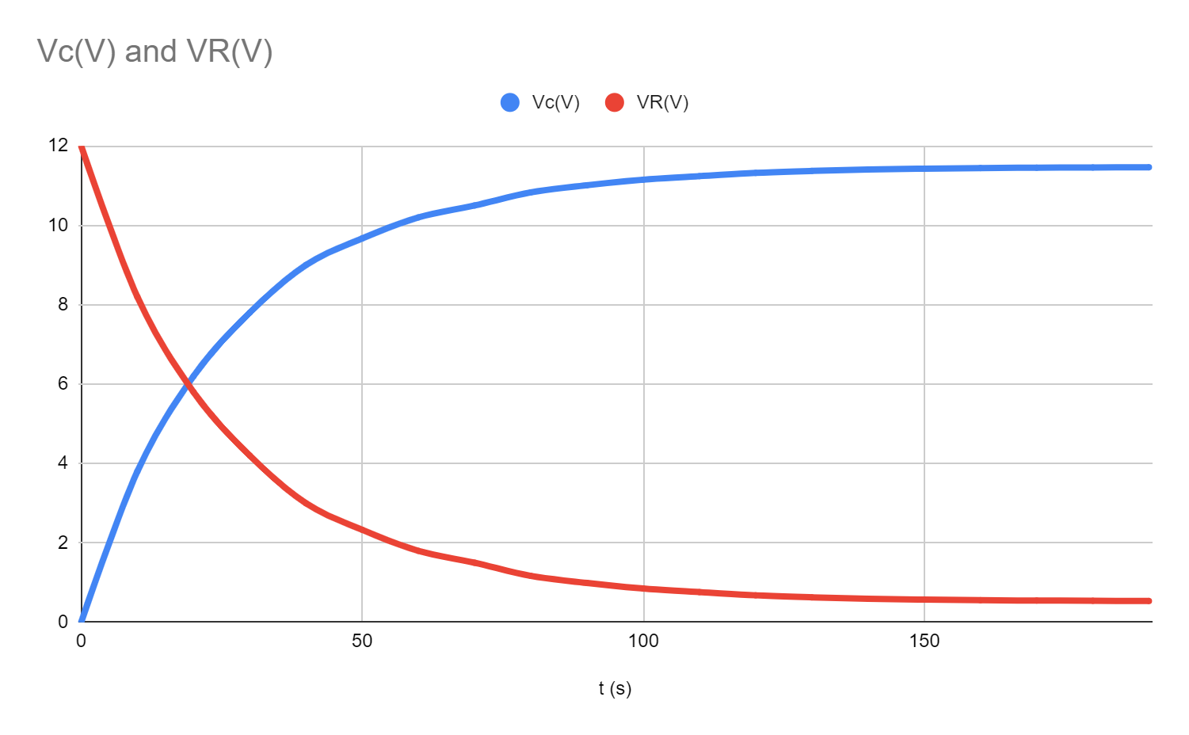

Graph Made Using Exponential Equations

VC = E( 1 – e-t/RC ) , VR = E e-t/RC

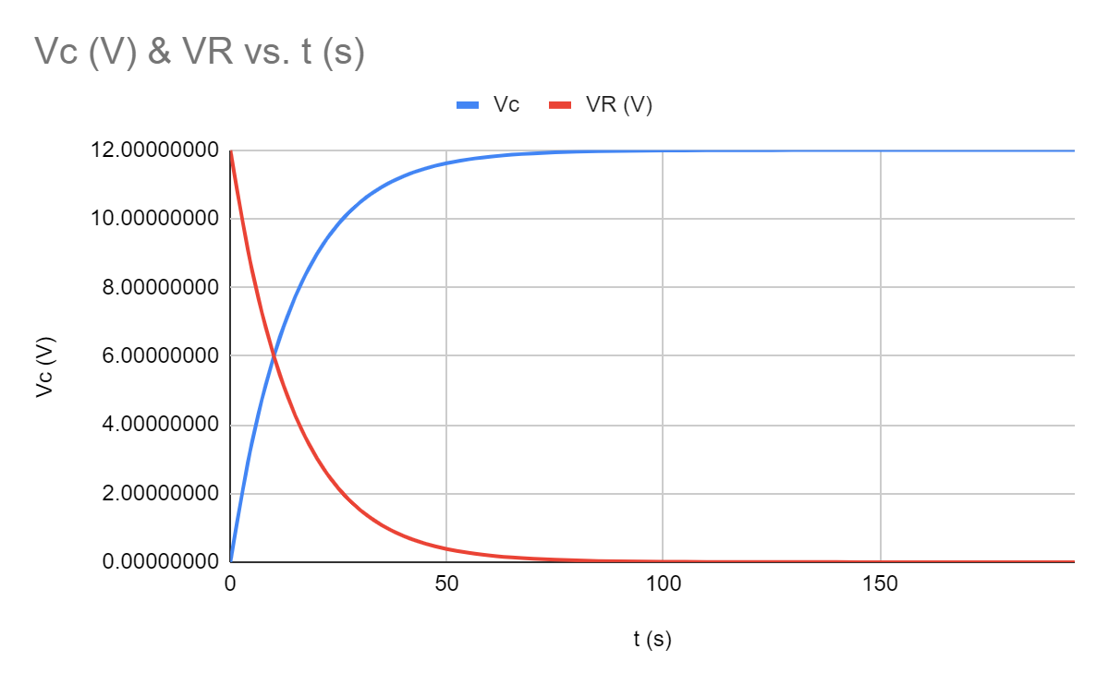

Conclusion:

Our values for the capacitance of the capacitor was strange with the LC meter reading it as 145µF, while our lab produced a result of 269.946µF. The LC meter’s reading is about 34% below the plate value and the lab’s value is about 22% above the plate value. We aren’t entirely sure why this occurred since our measurements for the RC constant were consistent showing that we at least performed the lab correctly. This could be the fault of the capacitor not being built correctly, however, we did use a spare one from the same company and got similar results for both the lab and LC meter. This also could the fault of some form of interference with other components, but we can’t fully identify a potential cause for this.

Our graphs of Vc and VR both exhibit similar trends but with some differences. As time continued, the value of Vc didn’t change as quickly as the theoretical values but both did trend towards 12V for Vc and towards 0 for VR. VR will more than likely not reach 0V due to the fact that before we began the experiment there was a voltage drop across the capacitor of about 5mV while shorted. This would probably have resulted in the graphs not perfectly trending towards 12 and 0 volts if we allowed the experiment to continue longer. This difference is more than likely the result of having resistance with the wiring of some of the components which allows for some voltage drops other than the components in the system.